Figure S1

A

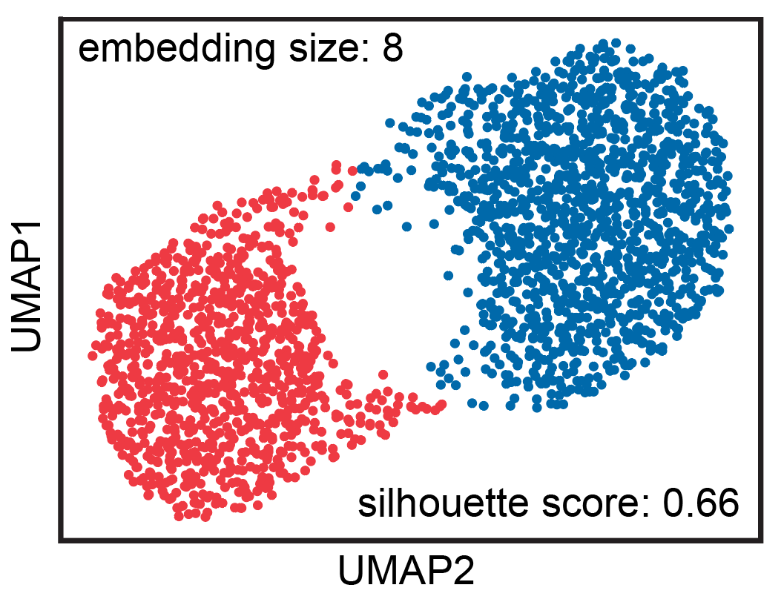

B

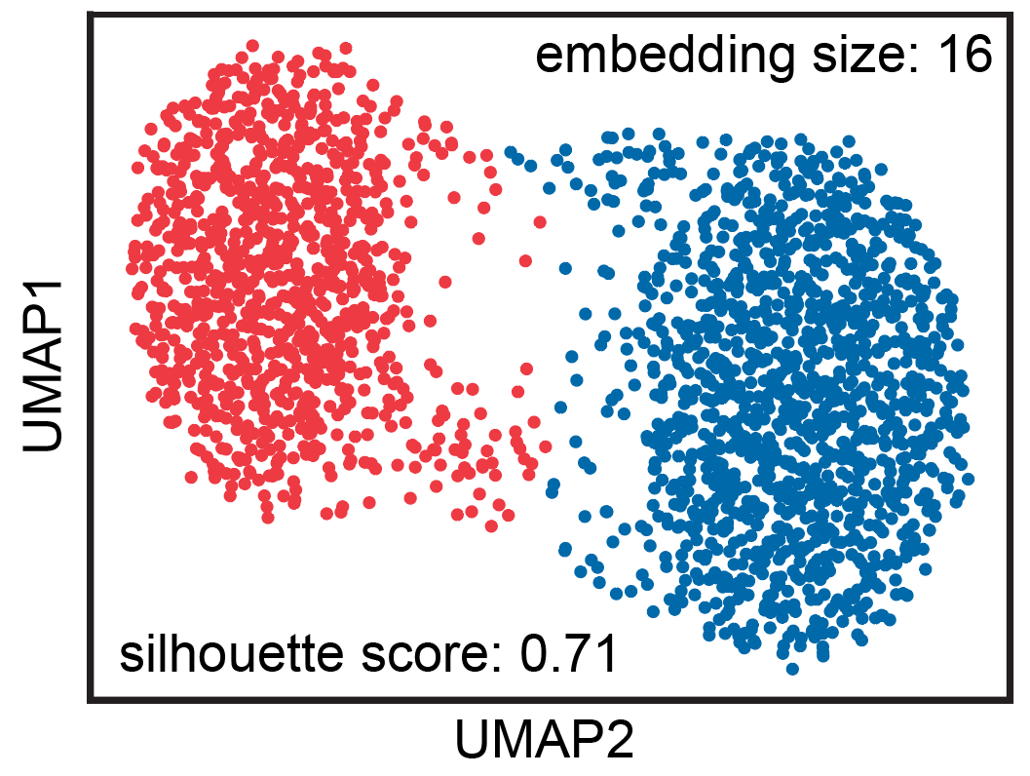

C

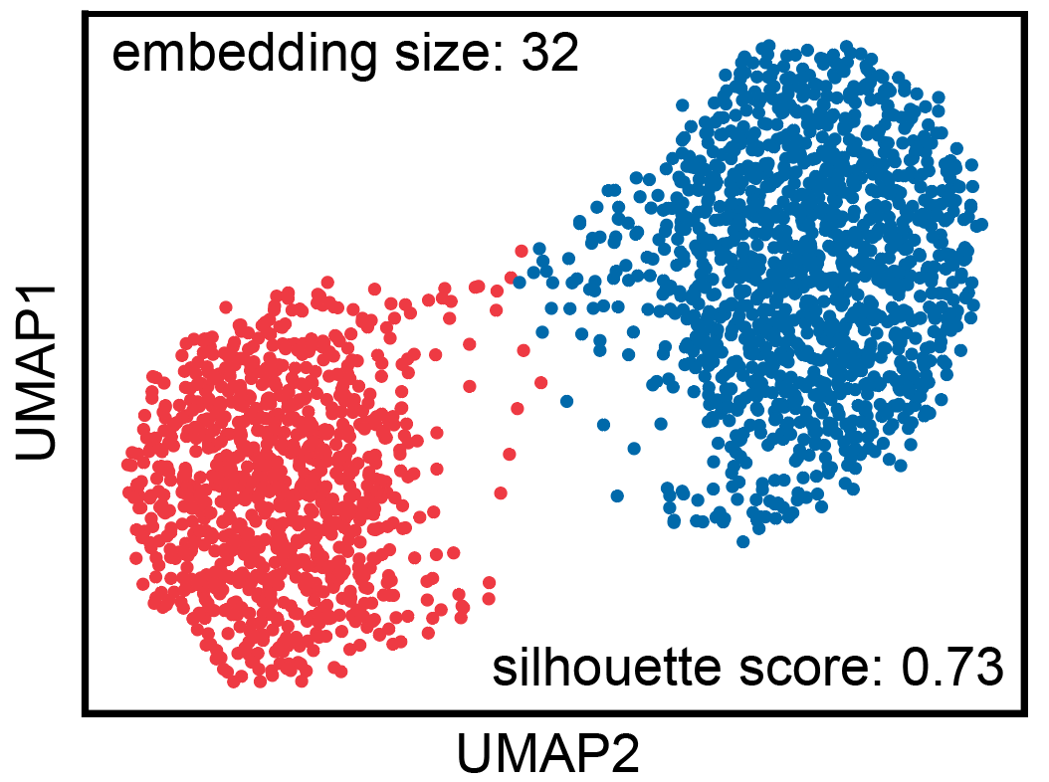

D

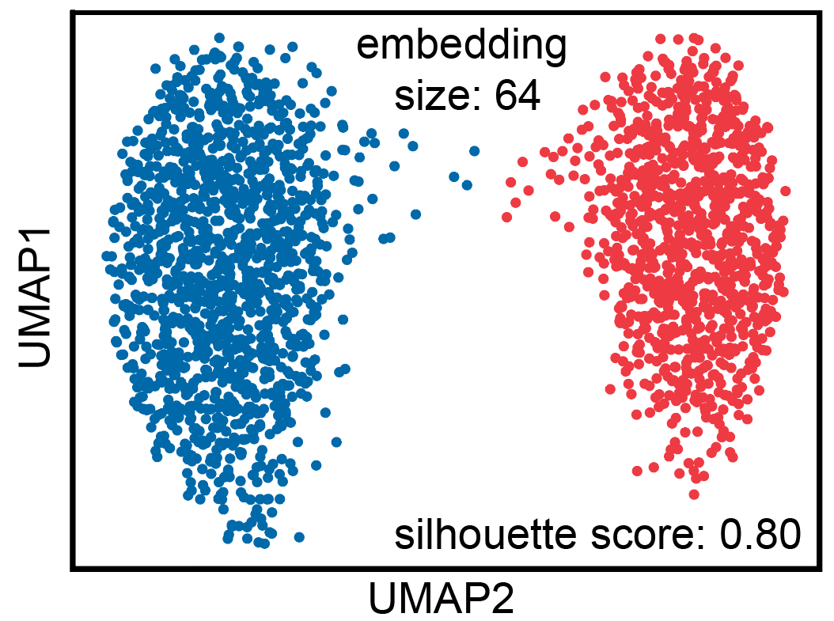

E

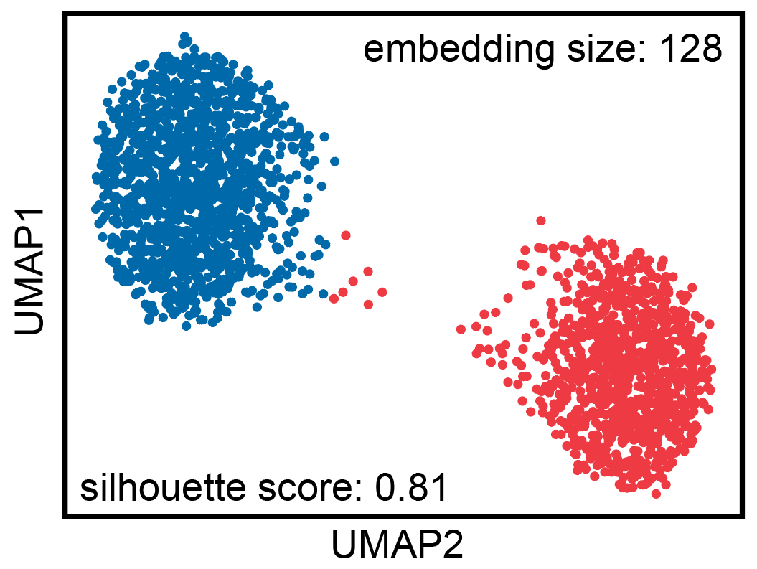

F

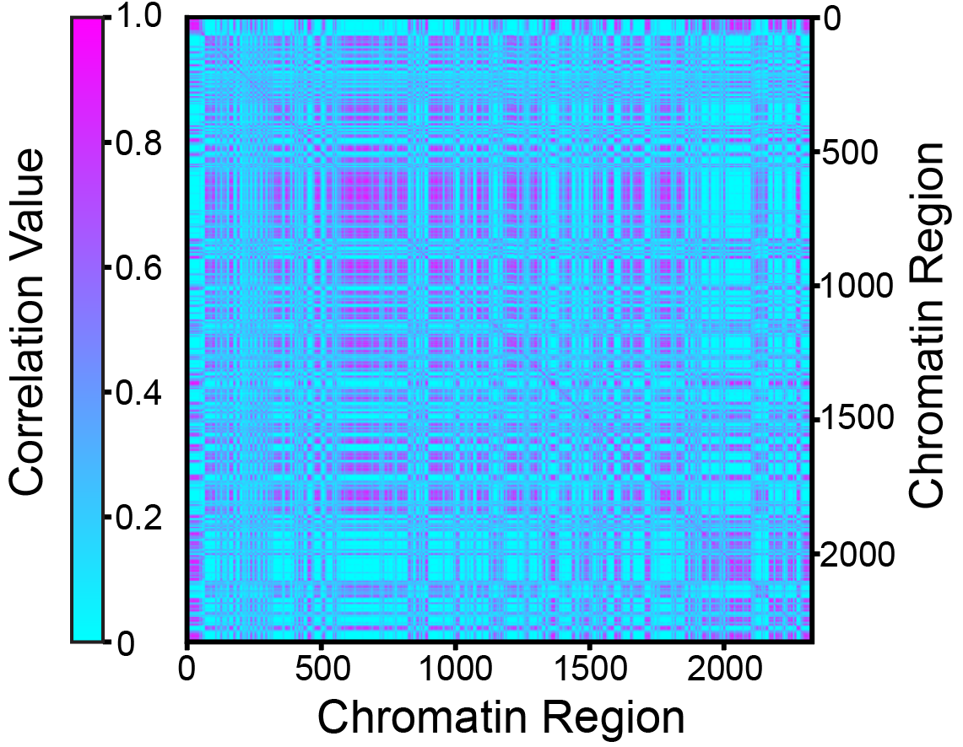

G

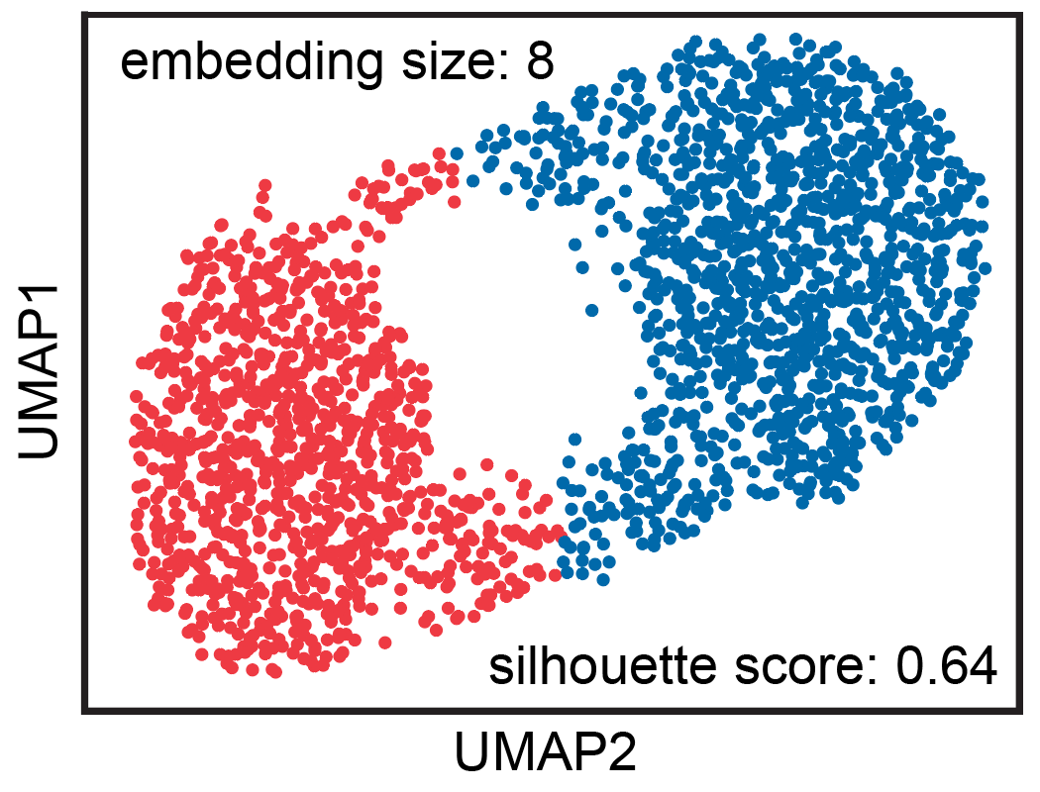

H

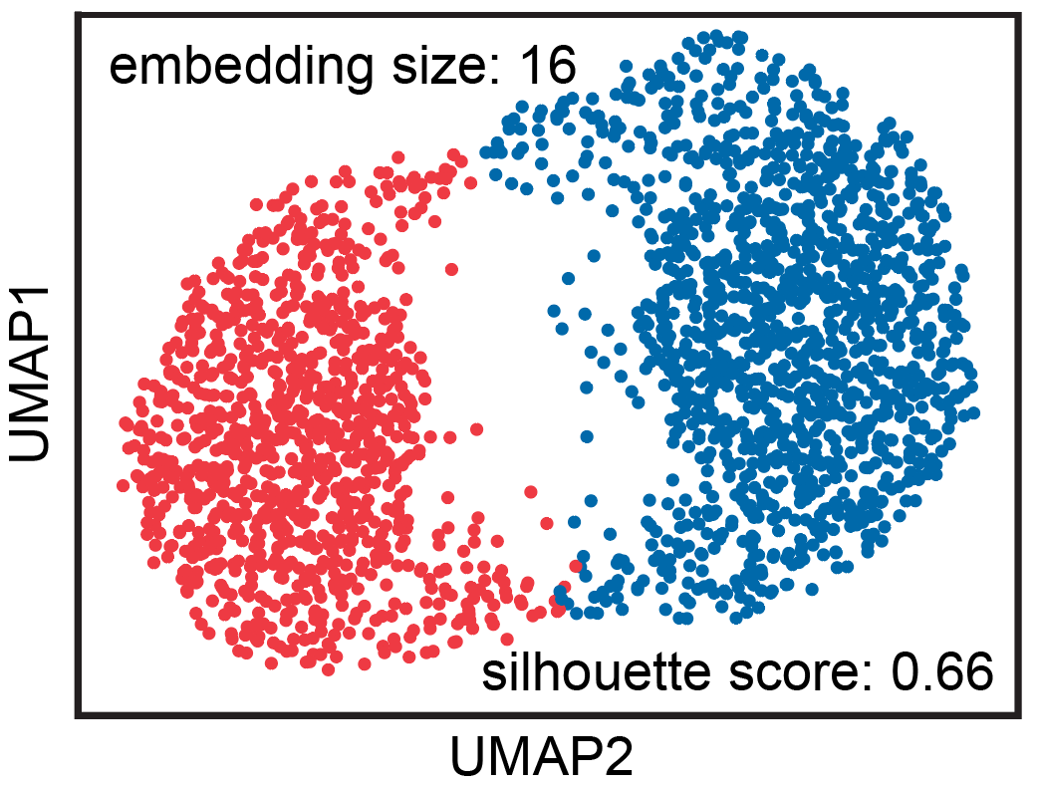

I

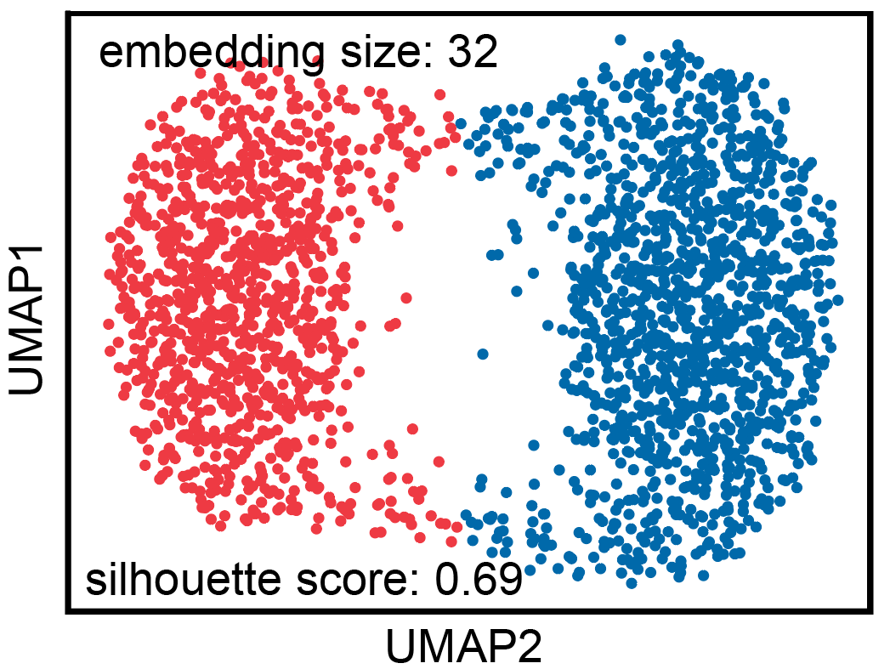

J

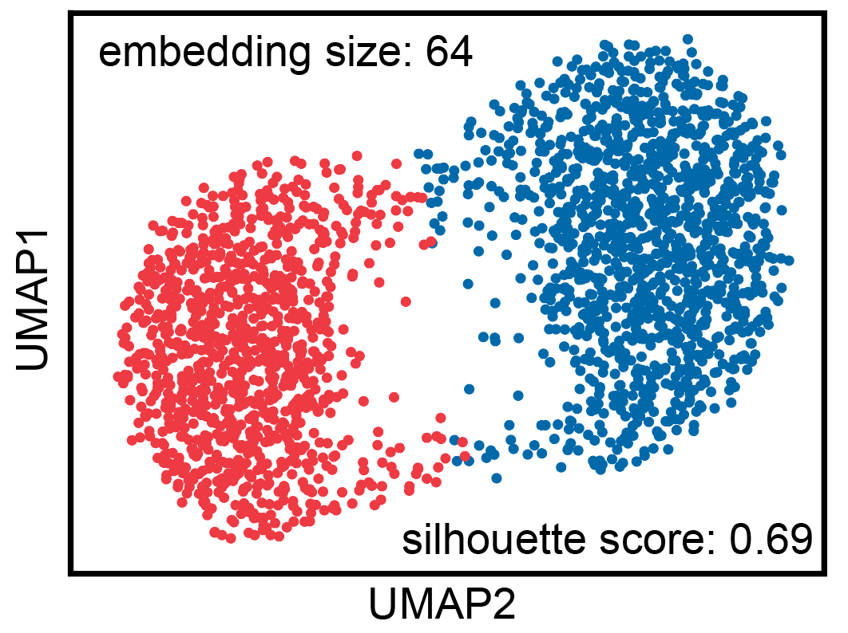

K

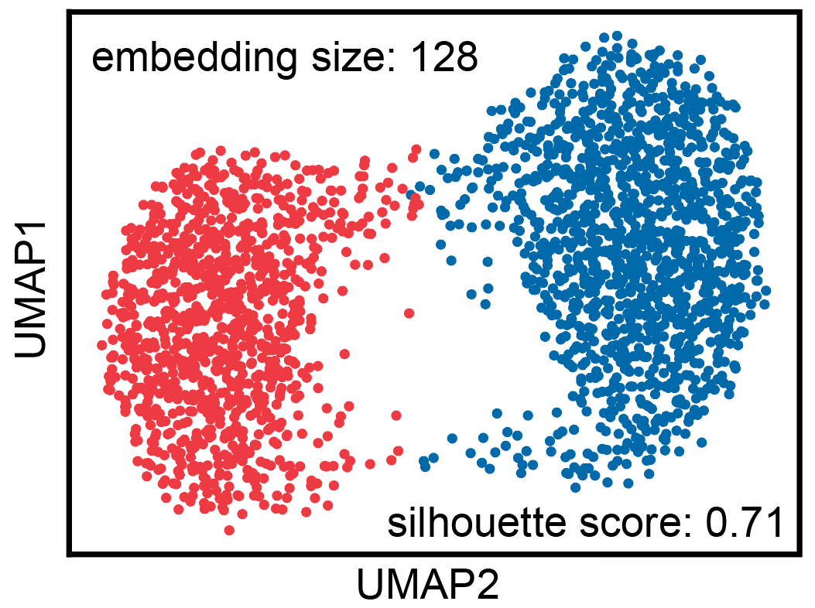

L

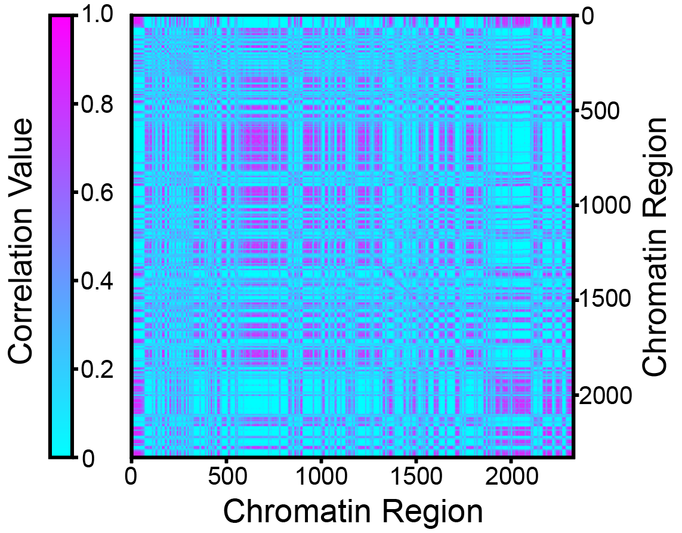

M

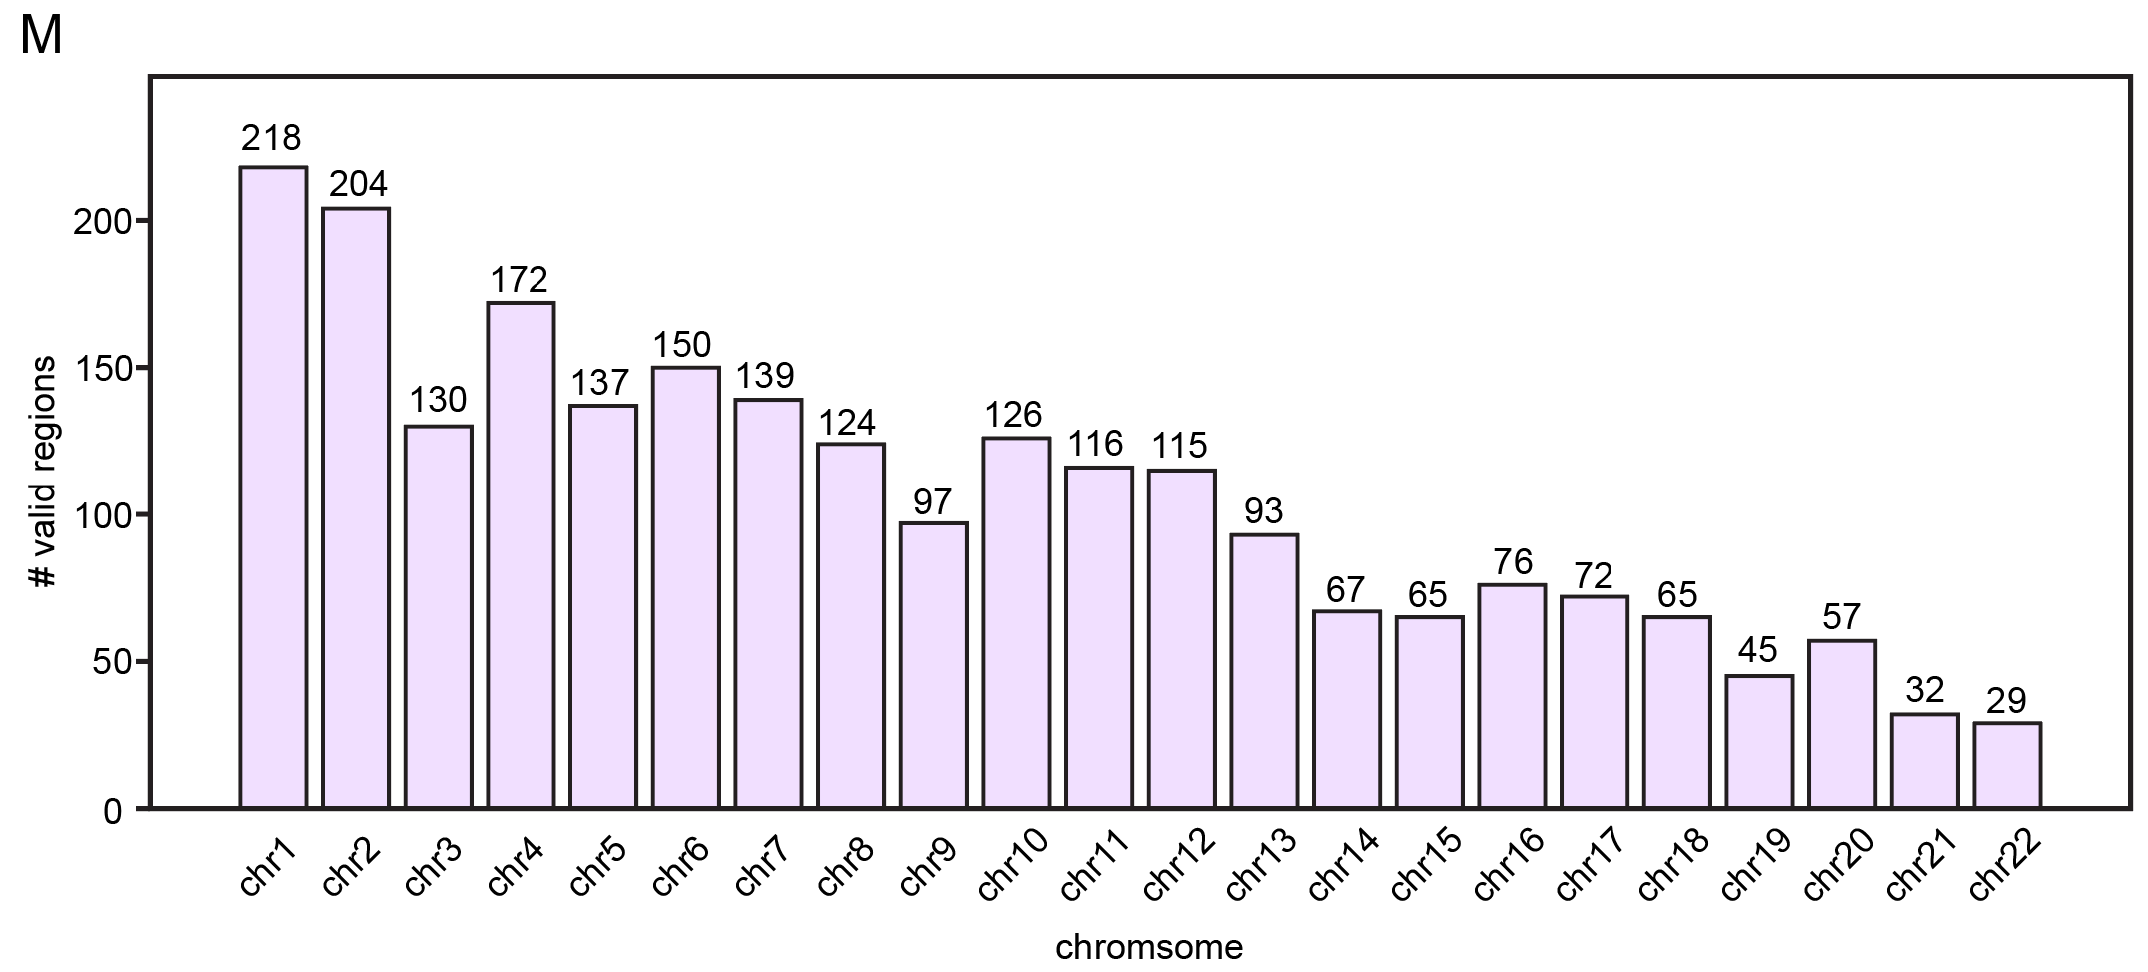

Figure S1. UMAP and correlation heatmap of bulk tissue data (HFC and BRG).

(A-E) UMAP of HFC dataset with different embedding size (8, 16, 32, 64, 128).

(F) Correlation heatmap of HFC dataset.

(G-K) UMAP of BRG dataset with different embedding size (8, 16, 32, 64, 128).

(L) Correlation heatmap of BRG dataset.

(M) Valid region distribution on each chromosome.

Figure S2

A

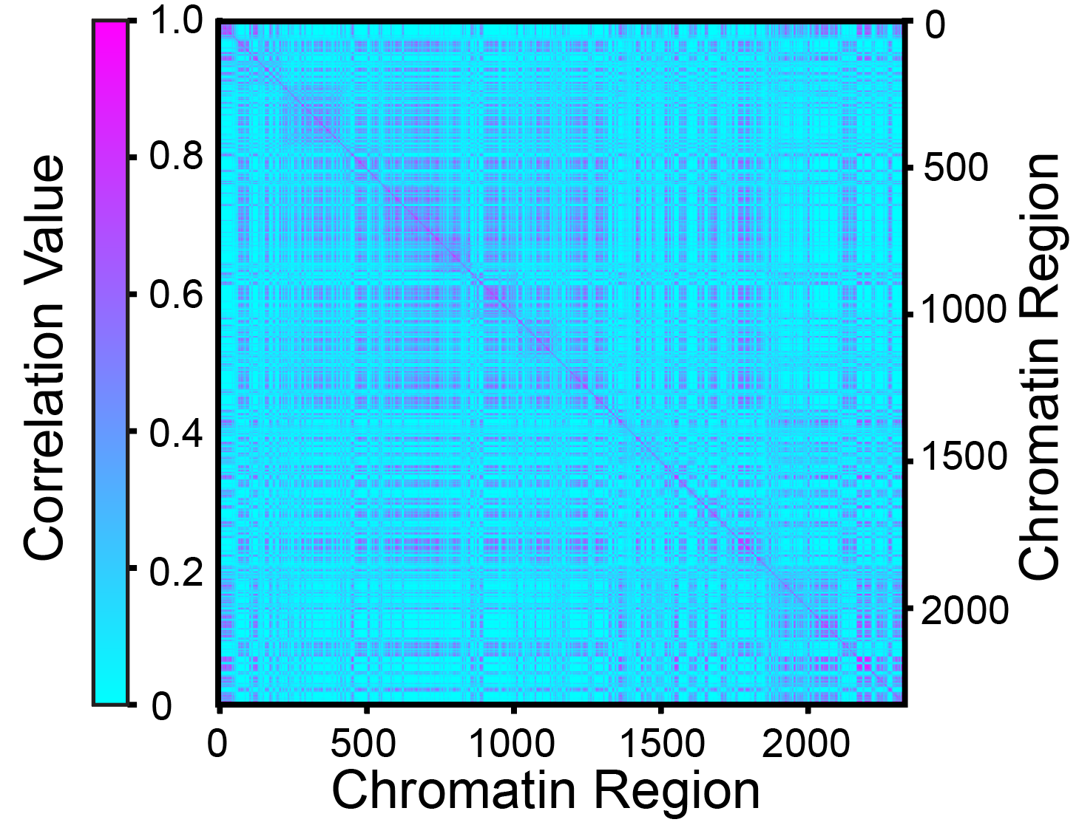

B

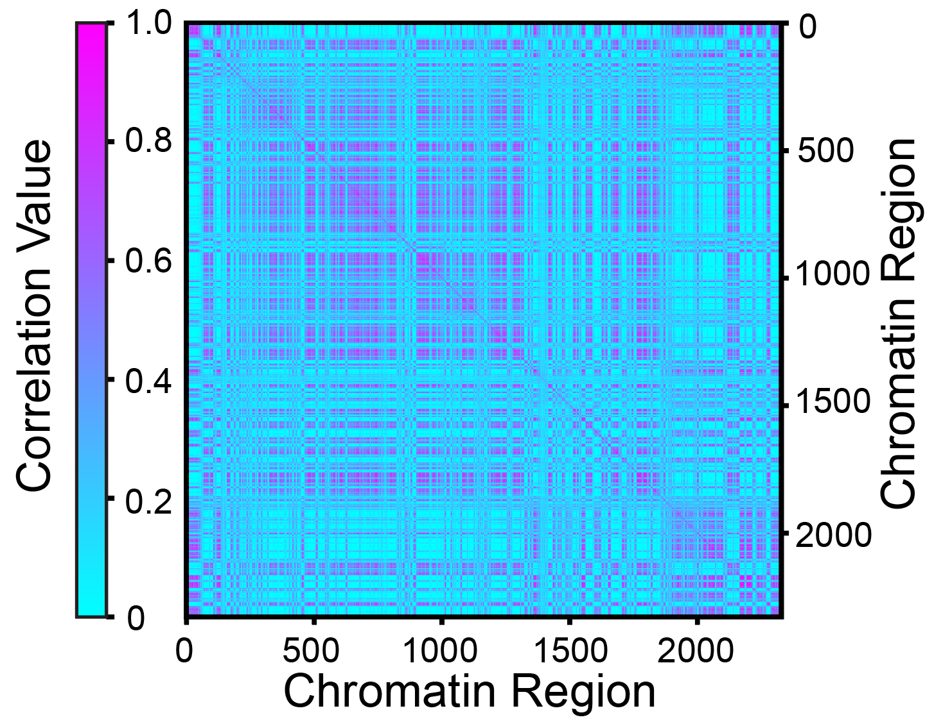

C

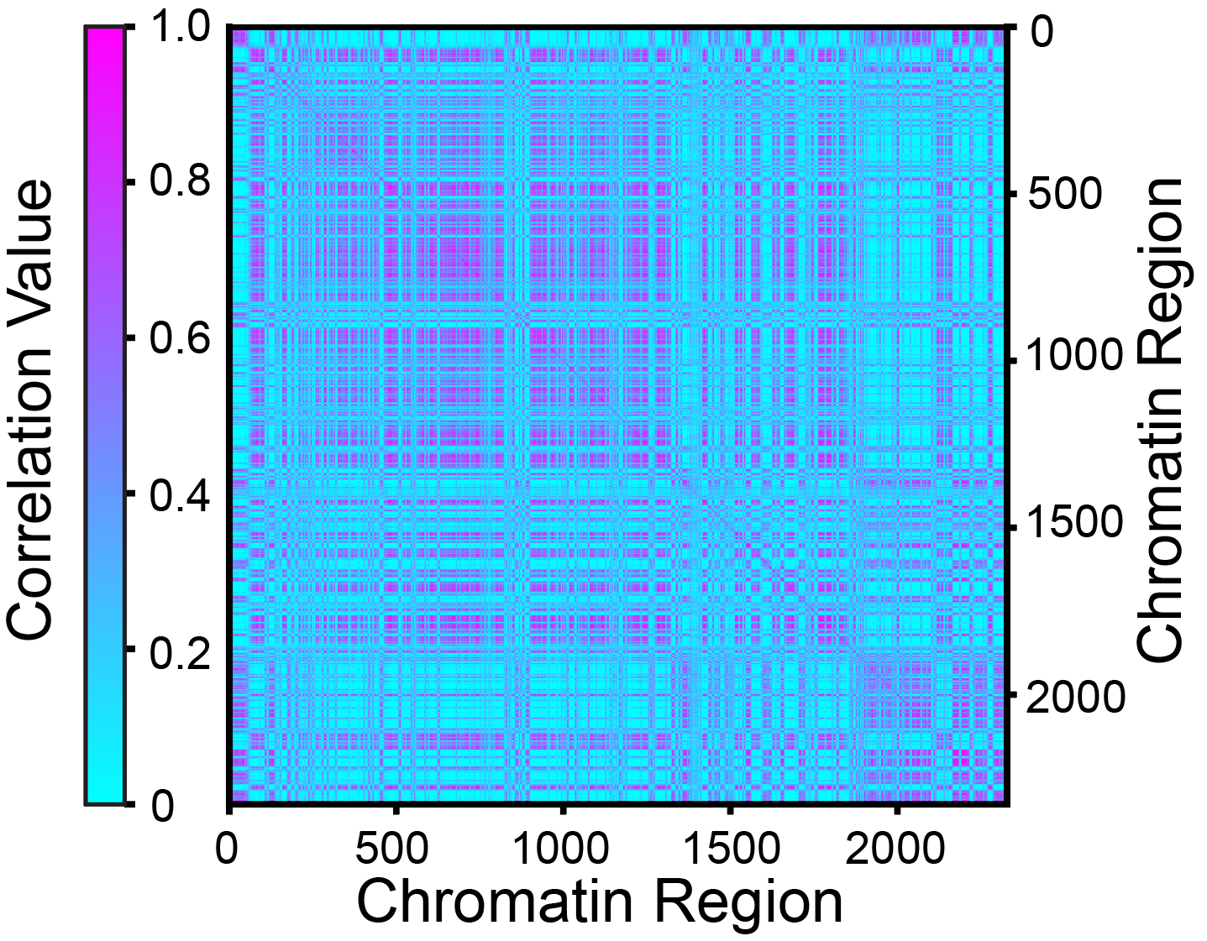

D

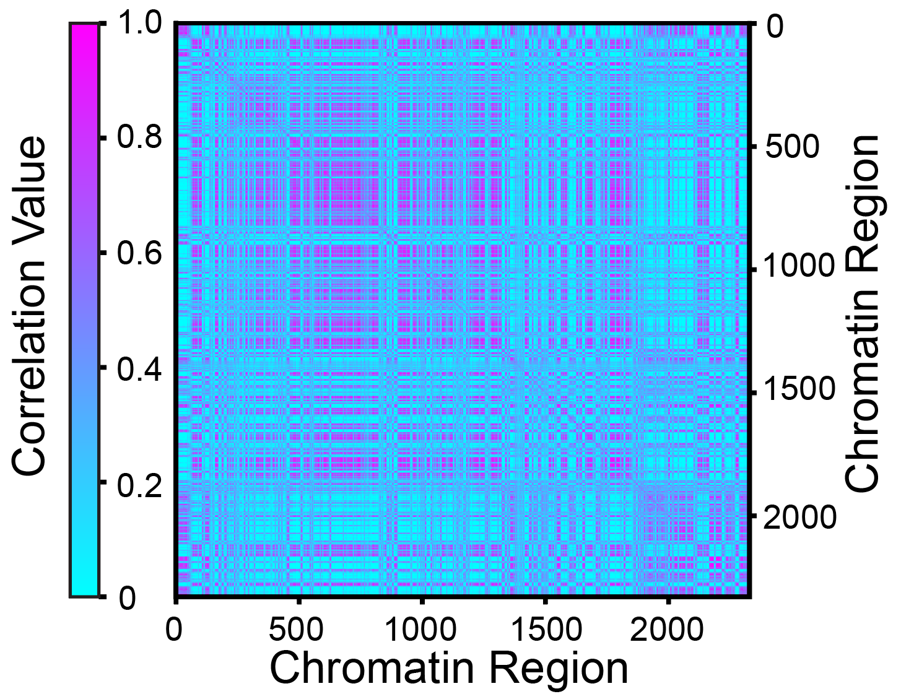

E

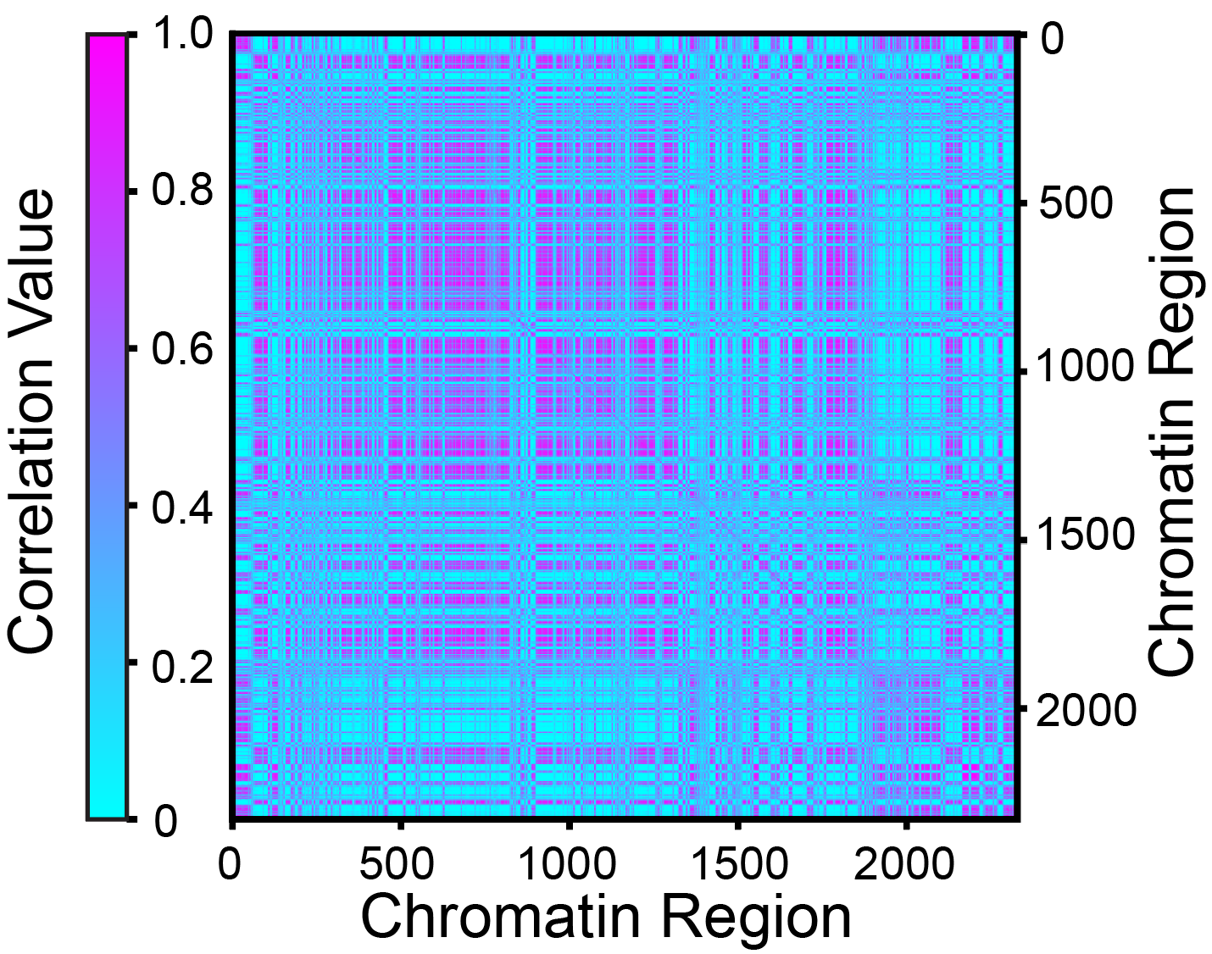

F

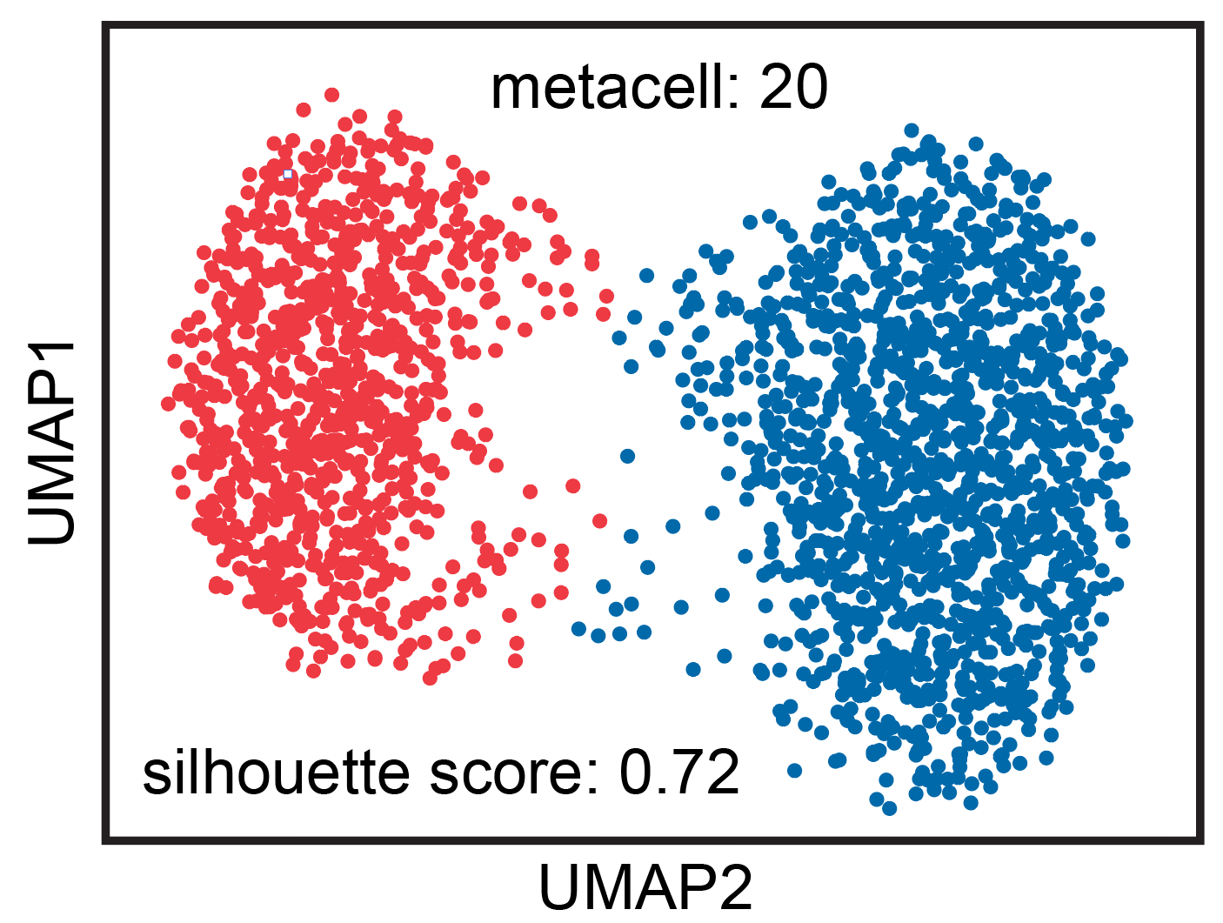

G

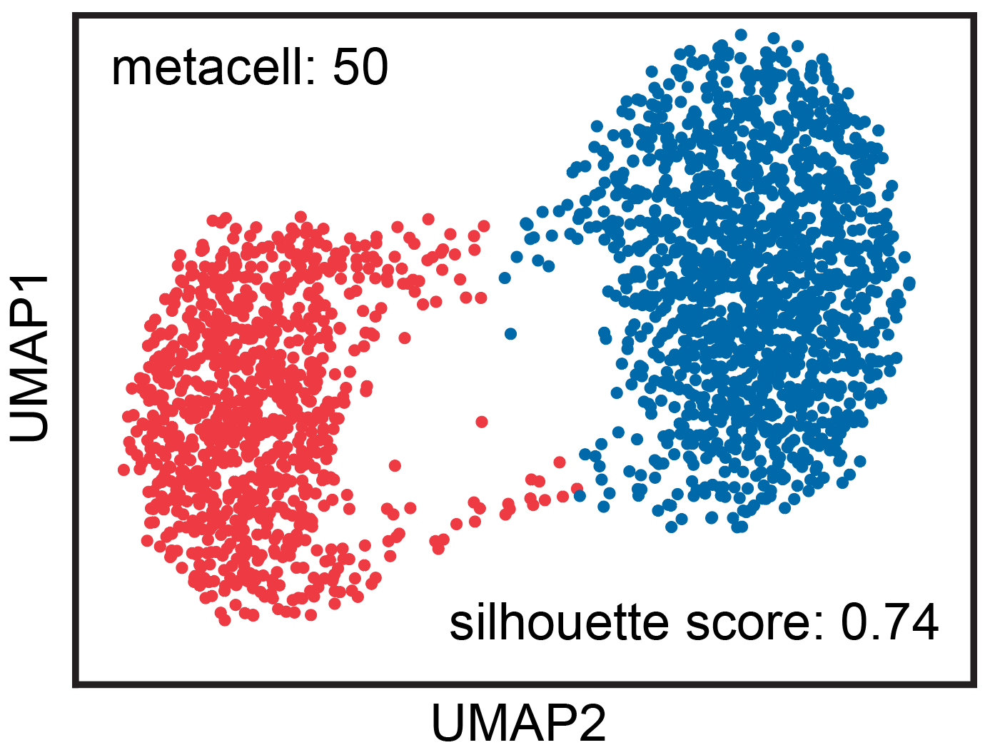

H

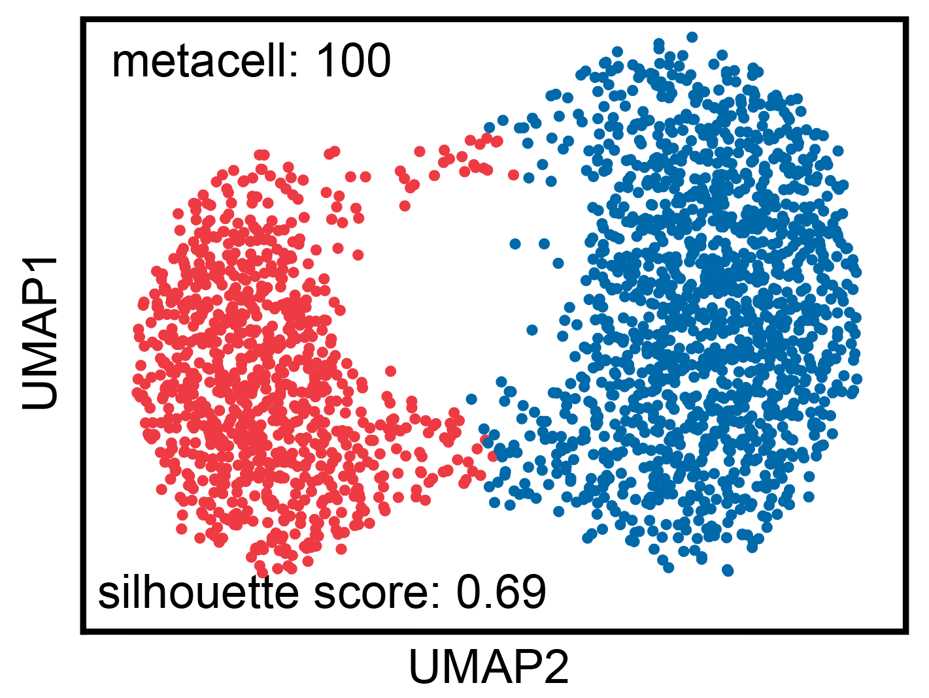

I

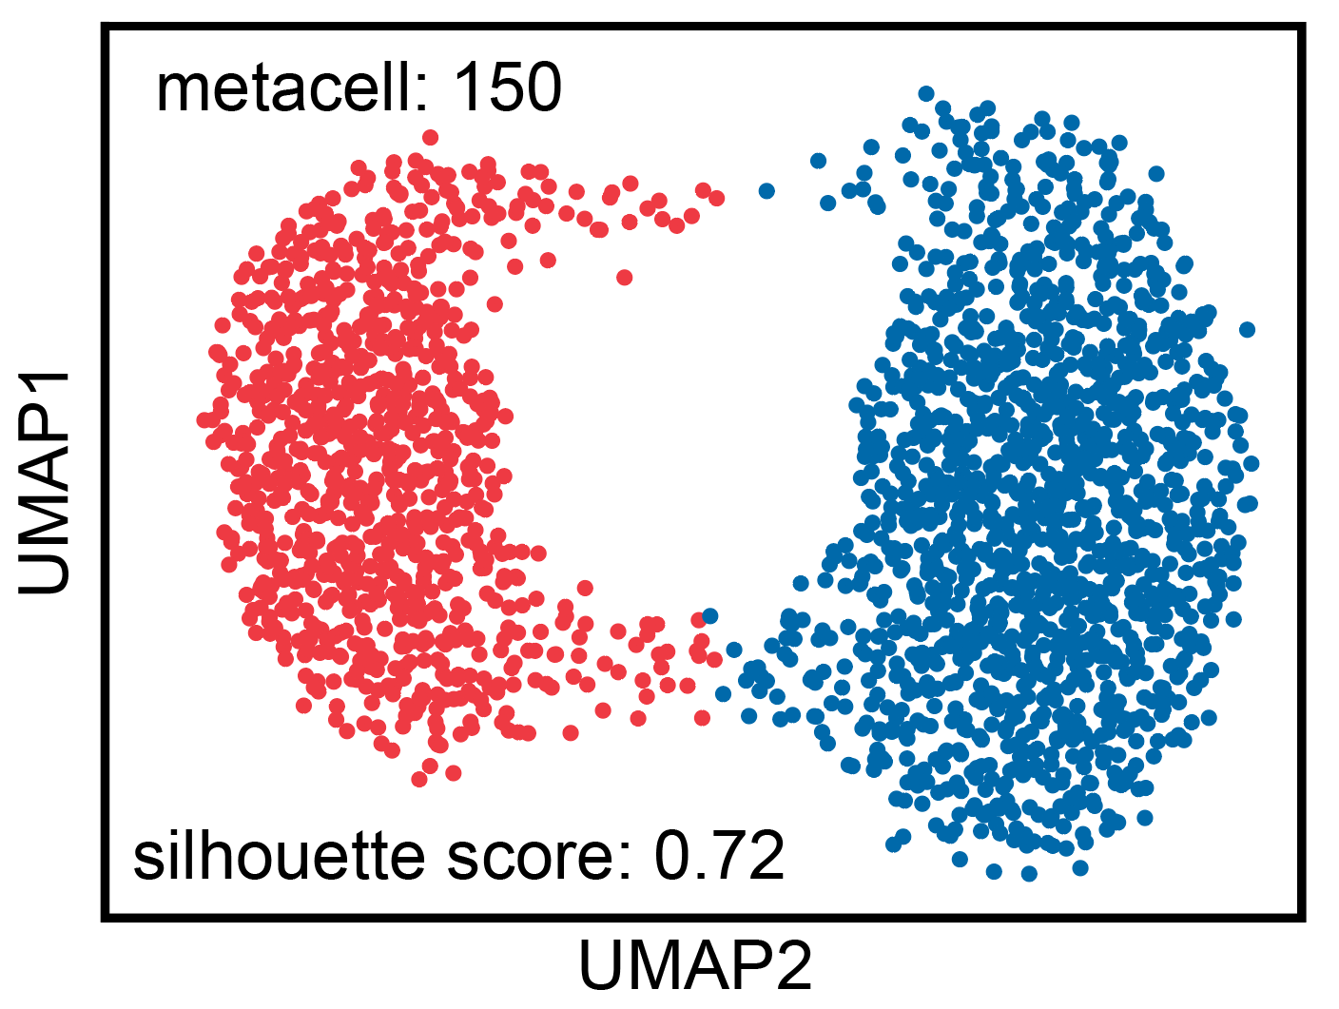

J

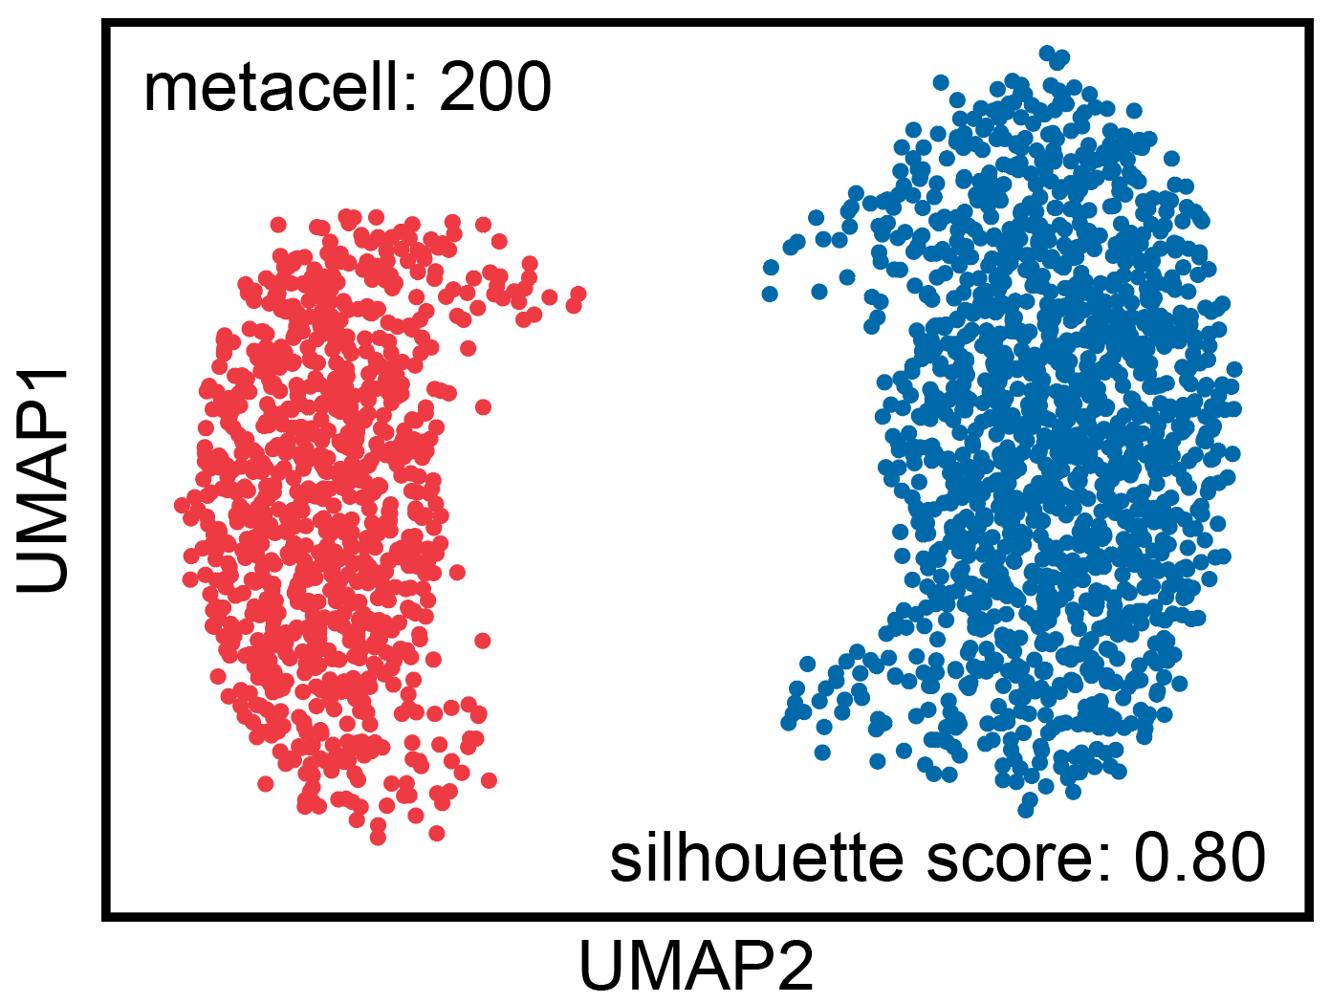

Figure S2. Correlation heatmap and UMAP with different metacell numbers. Control samples with microglia cell types are used. Resolution: 1000K, embedding size:32, damping factor: 0.85 and negative samples: 3.

(A-E) Correlation heatmap with different metacell numbers (20, 50, 100, 150, 200).

(F-J) UMAP with different metacell numbers (20, 50, 100, 150, 200).

Figure S6

A

B

C

D

E

F

Figure S6. Running time with different embedding size, resolution, damping factor and negative sample

(A) Running time with different embedding size (8, 16, 32, 64, 128). Resolution: 1000K, damping factor: 0.85, negative samples:3.

(B) Running time with different embedding size (8, 16, 32, 64, 128). Resolution: 500K, damping factor: 0.85, negative samples:3.

(C) Running time with different embedding size (8, 16, 32, 64, 128). Resolution: 100K, damping factor: 0.85, negative samples:3.

(D) Running time with different resolution (1000K, 500K, 100K). Embedding size: 32, damping factor: 0.85, negative samples:3.

(E) Running time with different damping factor (from 0.1 to 0.9). Resolution: 1000K, embedding size: 32, negative samples:3.

(F) Running time with different negative samples (from 1 to 100). Resolution: 1000K, embedding size: 32, damping factor: 0.85.